Skills to Succeed Academy
Flexible, on demand and engaging
Skills to Succeed
Academy
Social Media Toolkit
Table of Contents
Skills to Succeed Academy
Flexible, on demand and engaging
Skills to Succeed Academy
Flexible, on demand and engaging
1. Purpose 4
2. Social Media Tips and Tricks 5
3. Talking about the Skills to Succeed Academy on Social Media 6
3.1 Key Messages 6
3.2 Example Tweets and Posts 6
3.3 How to Respond to Queries on Social Media 12

social media toolkit
1. Purpose
The aim of this toolkit is to help you talk about Accenture’s Skills to Succeed Academy on social media.
Communicating messages about the Skills to Succeed Academy on social media is a great way to engage your audience. Please keep messages aligned to the Skills to Succeed Academy’s core Marketing Messages. If you want to create messages that do not follow the core messages provided please contact the Skills to Succeed Academy Team on contact@s2sacademy.com.
2.Social media tips and tricks

- Be conversational, not overly corporate - You want to sound like a friendly colleague, not a formal corporation. Draw your audience in with a compelling reason to click the link. Use emojis or emoticons :) to keep it informal, when appropriate. Make sure you use “we” or “our” instead of saying for example “Accenture”
- Aim to be engaging, not overly technical - Take a colloquial approach, even when promoting complex topics. What’s your most interesting or surprising info? Use that as your hook
- Go for short & snappy text in your post - You only have a few seconds to grab a reader’s interest. Aim for clever phrases in a simple, eye-catching format
- Use images or videos to captivate your audience - It makes it more engaging provided it is relevant to the Skills to Succeed Academy
- Use dynamic, not dull, photography - Photos should pack a punch. Remember: You want readers to stop and take a longer look
- Make sure your post works for desktop and mobile - Most readers today are consuming your content via the small screen of a mobile phone. Can they read everything?
- Use # to start conversations - When talking about the Skills to Succeed Academy on social media use our hashtag #S2SAcademy
- Mention relevant @ twitter handles or profiles in your post to create engagement - It often starts conversation and increases the reach of your post. Engage with those that follow you, message you or talk about content related to you – retweet, like, reply and comment on content linked to your organisation
3. Talking about the Skills to Succeed Academy on social media
3.1 Key messages
Please see the Skills to Succeed Academy Marketing Messages for possible messaging that could be used in social media posts.

3.2 Example tweets and posts
This section contains suggestions for Tweets and posts which you can use to promote the Skills to Succeed Academy on social media.
The Tweets and posts come with either a picture, video or a GIF and you can see a selection of them by clicking here. You can find instructions on how to access the imagery in the table below.
Please note, you need to enter the access code your learners use where it says Access Code XXXXX. i.e Access Code XXXXX will not work when registering. Please do not share your Advisor Access Code on social media as these should not be used by learners.
Don’t forget to mention @accentureukjobs in your Twitter posts and we will try to help with engagement from our side.

# | Example tweets/posts | Imagery | Additional info
1 | The @AccentureUK #S2SAcademy has trained over 70,000 people so far. To find out more visit https://bit.ly/s2sacademy |  | Click the play button on top of the image to view it in Twitter  If you would like to use this GIF in your post get in touch by emailing contact@s2sacademy.com
2 | Looking for a new job but don’t know where to start? Use #S2SAcademy at https://bit.ly/s2sacademy & use Access Code XXXXXX to learn more #jobs |  | To use this picture in your post, simply right-click and ‘Save as Picture’ and upload onto social media as normal
3 | Registering for the #S2SAcademy is quick and easy. Just use learner access code XXXXXX when registering at https://bit.ly/s2sacademy to start your journey into employment |  | To use this picture in your post, simply right-click and ‘Save as Picture’ and upload onto social media as normal
4 | Looking for work but not sure what skills you have? Try the Identify Your Skills module in the Getting a Job course on #S2SAcademy. Register at https://bit.ly/s2sacademy using learner access code XXXXXX | 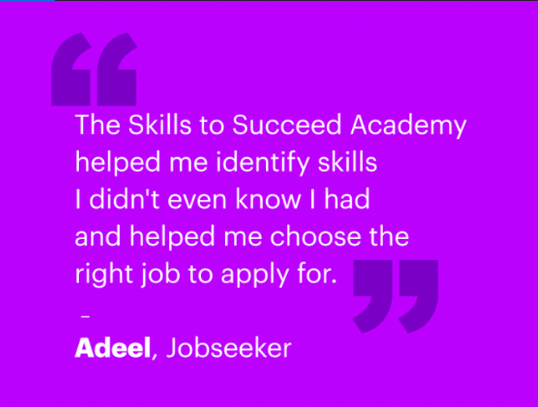 | Click the play button on top of the image to view the example in Twitter  If you would like to use this GIF in your post get in touch by emailing contact@s2sacademy.com
6 | Try the Identify Your Skills module from @AccentureUK 's Getting a Job course on #S2SAcademy. Register using learner access code XXXXXX at https://bit.ly/s2sacademy |  | To use this picture in your post, simply right-click and ‘Save as Picture’ and upload onto social media as normal
7 | If you want to stand out from the crowd don't send the same CV for every job application. Try the module on tailoring your CV from the Getting A Job course on #S2SAcademy https://bit.ly/s2sacademy, using access code XXXXXX #S2SAcademy | 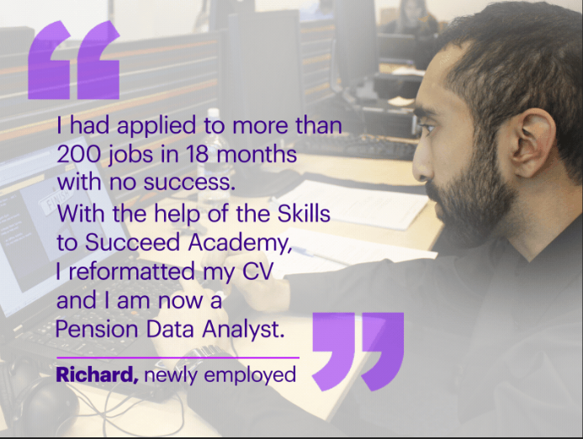 | Click the play button on top of the image to view the example in Twitter  If you would like to use this GIF in your post get in touch by emailing contact@s2sacademy.com
8 | Michelle had never worked before but got help from the #S2SAcademy to identify skills she could put on her CV. For CV top tips try the Getting a Job course at https://bit.ly/s2sacademy. Use learner access code XXXXXX to register | 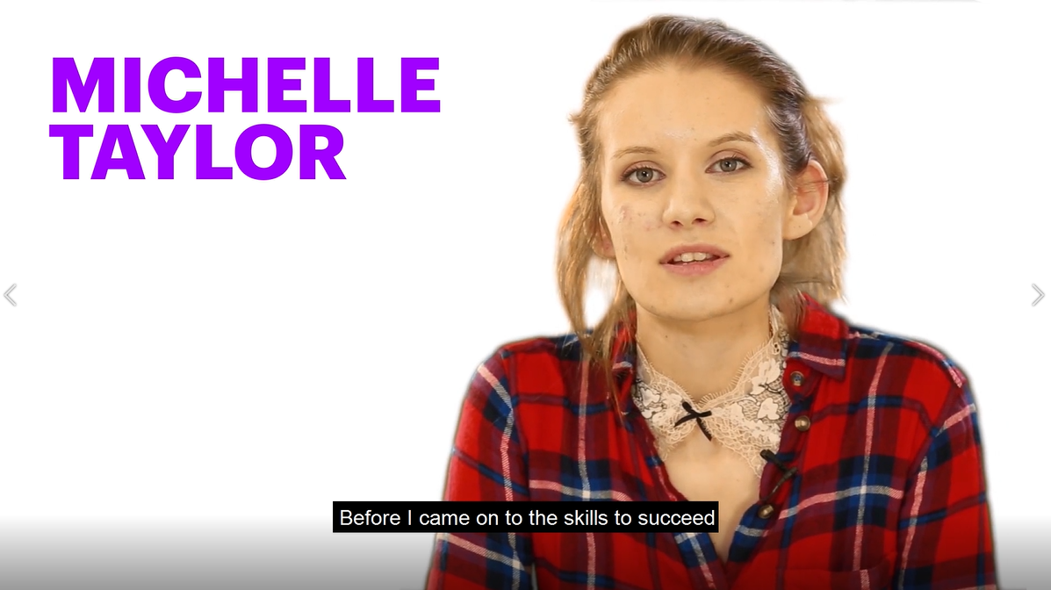 | Click the play button on top of the image to view the example in Twitter  If you would like to use this Video in your post get in touch by emailing contact@s2sacademy.com
9 | Need tips on networking your way into a job? Try Module 7 from the Getting a Job Course at #S2SAcademy https://bit.ly/s2sacademy. Use learner access code XXXXXX to register |  | To use this picture in your post, simply right-click and ‘Save as Picture’ and upload onto social media as normal
10 | Need tips on researching jobs? Use #S2SAcademy https://bit.ly/s2sacademy. Use learner access code XXXXXX to register and try Module 8 from the Getting a Job Course |  | To use this picture in your post, simply right-click and ‘Save as Picture’ and upload onto social media as normal
11 | . @AccentureUK 's #S2SAcademy can help you understand what job adverts are actually telling you. Check out the To Apply or Not to Apply module in the Getting a Job course. Register at https://bit.ly/s2sacademy with learner access code XXXXXX |  | To use this picture in your post, simply right-click and ‘Save as Picture’ and upload onto social media as normal
12 | Need help demonstrating your experience in interviews? Learn how the CAR Technique in the Getting a Job course can help! Register at #S2SAcademy https://bit.ly/s2sacademy using the learner access code XXXXXX | 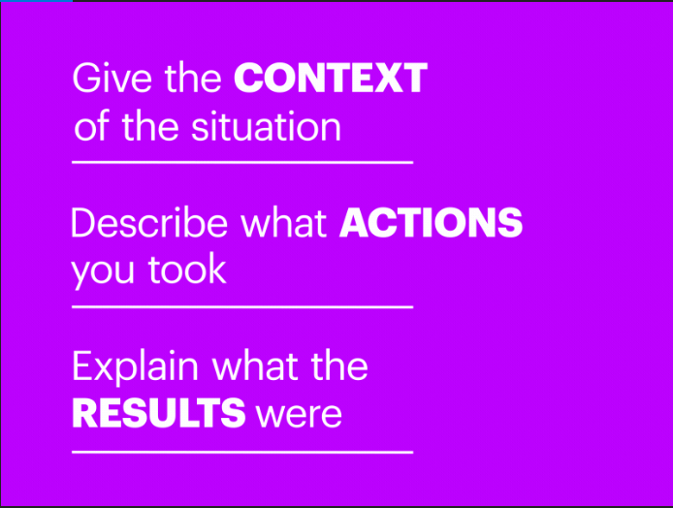 | Click the play button on top of the image to view the example in Twitter  If you would like to use this GIF in your post get in touch by emailing contact@s2sacademy.com
13 | Need help with competency questions for jobs? Try Module 10 in #S2SAcademy Getting a Job Course. Register at https://bit.ly/s2sacademy using learner access code XXXXXX |  | To use this picture in your post, simply right-click and ‘Save as Picture’ and upload onto social media as normal
14 | Check out modules on how to give your application form a boost in the Getting a Job course at #S2Sacademy. Register using learning access code XXXXXX at https://bit.ly/s2sacademy |  | To use this picture in your post, simply right-click and ‘Save as Picture’ and upload onto social media as normal
15 | Need help writing your cover letter? Try module 15 from #S2SAcademy in the Getting a Job Course. Register at https://bit.ly/s2sacademy using learner access code XXXXXX |  | To use this picture in your post, simply right-click and ‘Save as Picture’ and upload onto social media as normal
16 | Jamie's interview skills kept letting him down. Jamie got the job by practicing for interviews using @AccentureUK #S2SAcademy. Register at https://bit.ly/s2sacademy using learner access code XXXXXX | 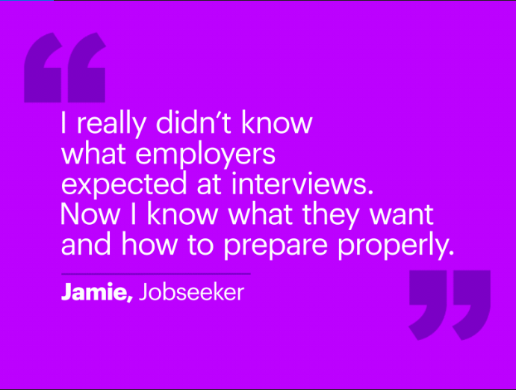 | Click the play button on top of the image to view the example in Twitter  If you would like to use this GIF in your post get in touch by emailing contact@s2sacademy.com
17 | #S2SAcademy can help you stand out in a job interview. Try the interview modules in the Getting a Job course. Register as a learner at https://bit.ly/s2sacademy using access code XXXXXX |  | To use this picture in your post, simply right-click and ‘Save as Picture’ and upload onto social media as normal
18 | . @AccentureUK 's #S2SAcademy's simulated interviews let you practice for real life situations! Check out Sam and FuturoSystems in the Getting a Job course at https://bit.ly/s2sacademy and register using learner access code XXXXXX | 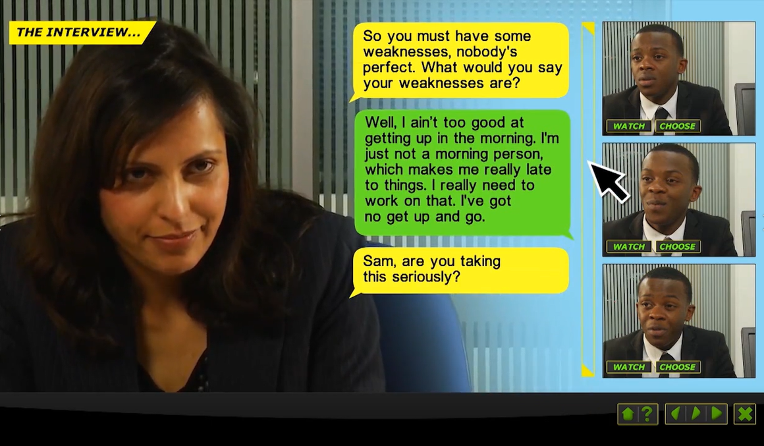 | Click the play button on top of the image to view the example in Twitter  If you would like to use this Video in your post get in touch by emailing contact@s2sacademy.com
19 | Did you know that 94% of employers use LinkedIn to find qualified candidates? Boost your profile with the Online Professional Presence module in the Getting a Job course at #S2SAcademy. Register at https://bit.ly/s2sacademy using learning access code XXXXXX |  | To use this picture in your post, simply right-click and ‘Save as Picture’ and upload onto social media as normal
20 | Ensure your social media profile tells the right story with the #S2SAcademy - check out the Online Professional Presence module in the Getting a Job course at https://bit.ly/s2sacademy. Register using learner access code XXXXXX |  | Click the play button on top of the image to view the example in Twitter  If you would like to use this GIF in your post get in touch by emailing contact@s2sacademy.com
21 | Never been in work before? Don’t know what to expect? The #S2SAcademy Success in Work course will teach you. Try it at https://bit.ly/s2sacademy and use learner access code XXXXXX to register |  | To use this picture in your post, simply right-click and ‘Save as Picture’ and upload onto social media as normal
22 | About to start a job or want tips to succeed in work? Go to #S2SAcademy https://bit.ly/s2sacademy and try the Success in Work course. Register using learner access code XXXXXX |  | To use this picture in your post, simply right-click and ‘Save as Picture’ and upload onto social media as normal
23 | Want to know how to take ownership of your career? Try the #S2SAcademy at https://bit.ly/s2sacademy and use learner access code XXXXXX to register |  | To use this picture in your post, simply right-click and ‘Save as Picture’ and upload onto social media as normal
24 | Join Pedro and help support jobseekers using the #S2SAcademy. Find out more here https://www.accenture.com/gb-en/about/corporate-citizenship/online-learning #MakingaDifference | 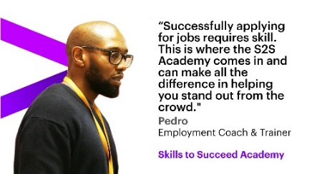 | To use this picture in your post, simply right-click and ‘Save as Picture’ and upload onto social media as normal
25 | Meet Faisal and find out how he used the #S2SAcademy to improve his CV and get the job by clicking here https://www.accenture.com/gb-en/about/corporate-citizenship/online-learning |  | Click the play button on top of the image to view the example in Twitter  If you would like to use this Video in your post get in touch by emailing contact@s2sacademy.com
26 | Faisal loved the fact that the #S2SAcademy could be used from the comfort of his own home. Try it at https://bit.ly/s2sacademy and use learner access code XXXXXX to register | 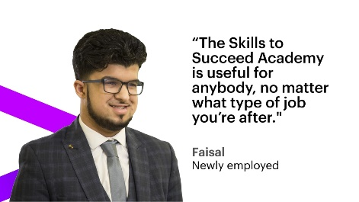 | To use this picture in your post, simply right-click and ‘Save as Picture’ and upload onto social media as normal
27 | Having learning difficulties can sometimes add additional challenges to finding a job. Read why Luke found @AccentureUK #S2SAcademy so helpful by clicking here https://www.accenture.com/gb-en/about/corporate-citizenship/online-learning | 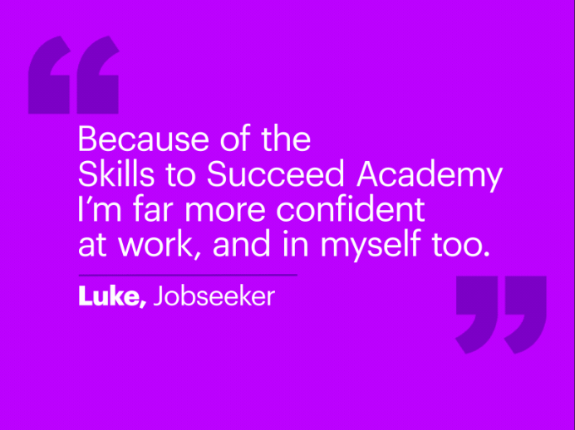 | Click the play button on top of the image to view the example in Twitter  If you would like to use this GIF in your post get in touch by emailing contact@s2sacademy.com
28 | Are you supporting people with employability skills and would like to use the #S2SAcademy? Read more here http://bit.ly/abouts2sa and get in touch at contact@s2sacademy.com #MakingaDifference | 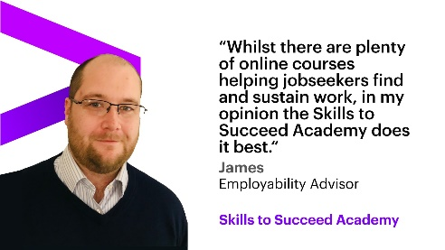 | To use this picture in your post, simply right-click and ‘Save as Picture’ and upload onto social media as normal

3.3 How to respond to queries on social media

You can use the following suggested responses to help you post back to resolve the query.

Query | Response
Want more information about why is was created | Check out https://bit.ly/s2sacademy to find out why #S2SAcademy was created and watch the video at the top of the page to see what’s included
Want more information about what it is | The #S2SAcademy is free online employability skills training. Watch this video to find out more https://goo.gl/pFXxQl
Problems logging in | Check you entered your email & password correctly. If you enter your password incorrectly 3 times your account will be locked for 30 mins
Problems registering | Ensure you enter access code [insert your access code here] in learner registration, complete all the fields & accept the terms of use
Problems with Access Code | Make sure you are using the access code [insert your access code here] under learner registration & don’t include any spaces
Can’t remember password | Click here https://goo.gl/gjUayL and enter your email. You’ll receive an email letting you choose a new password
Unsure which modules to do | If you aren’t sure which modules to do, be sure to complete the pre-assessment. Click on ‘Take Assessment’ on the course menu screen when you log into https://bit.ly/s2sacademy
Why is it free/will I ever need to pay for it | You will never need to pay for the #S2SAcademy. For more info on why it was created click here http://bit.ly/S2SAlearnmore

